Electronics Documentation

1. Electronics Block Diagram
Show signal and power flow
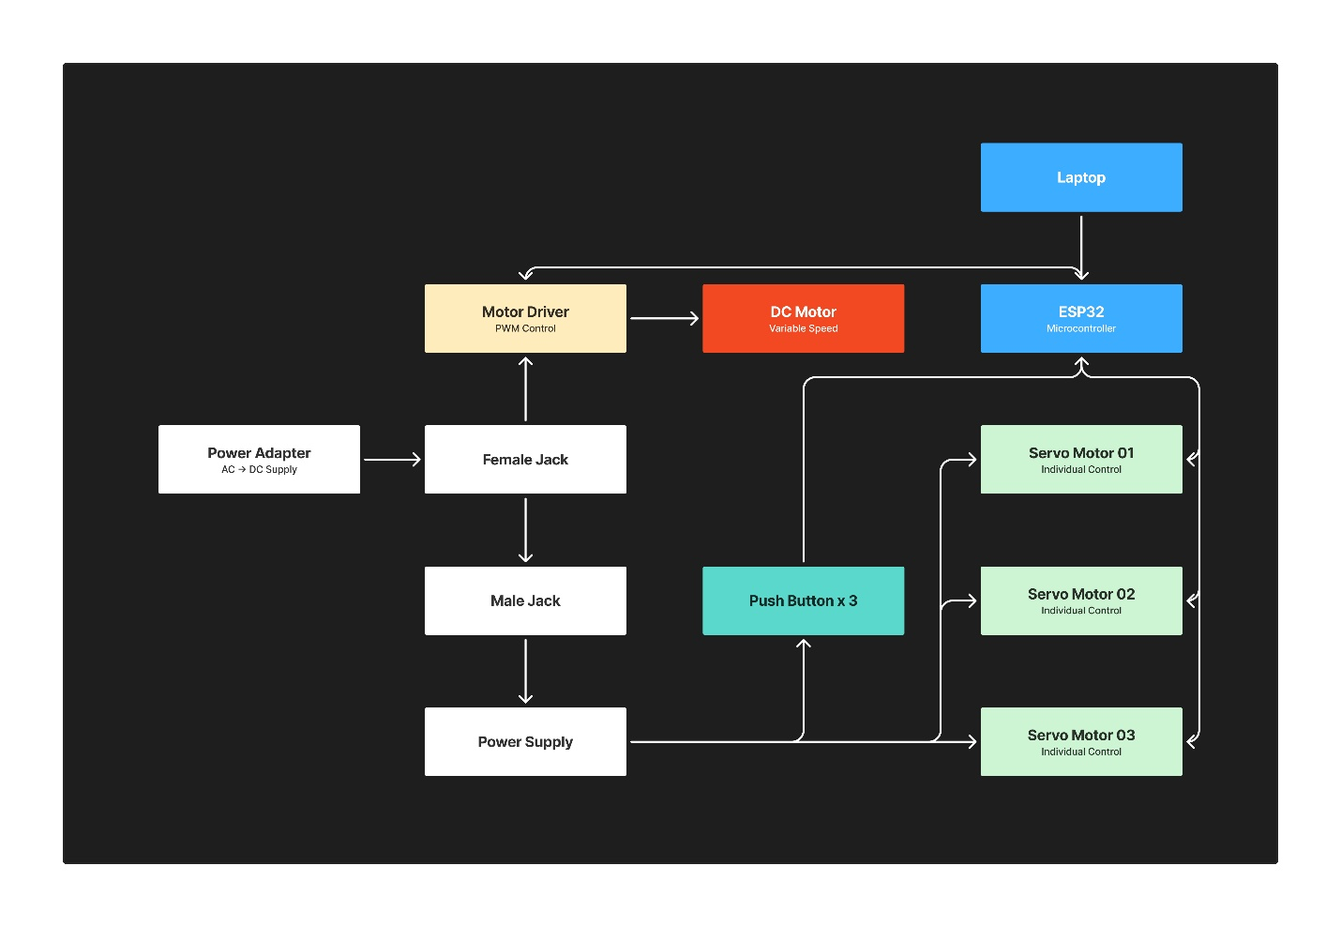

2. Components Table
Component | Quantity | Purpose | Justification
Servo Motor | 3 | To move the turret along the horizontal and vertical planes, and also trigger the rubberband mechanism. | Step-by-step rotatory movement is required for accurate alignment control in the hands of the user.
DC Motor | 1 | To rotate the spinning wheel as the obstacle unidirectionally. | With adjustable duty cycles/rotational speed, we can add layers of difficulty.
Push Button | 3 | To have three speeds of the DC Motor accessible through this system. | The opening/closing mechanism of the push buttons produces two distinct values.
Motor Driver | 1 | To amplify the PWM control signal from the ESP32 and drive the DC Motor at variable speeds. | The ESP32 cannot supply sufficient current to drive a DC motor directly; a dedicated driver ensures safe and controlled power delivery.
ESP32 | 1 | To serve as the central microcontroller, receiving commands from the laptop and coordinating all motors and inputs. | Its built-in WiFi, multiple PWM channels, and GPIO pins make it capable of managing the DC motor, three servos, and push buttons simultaneously.
Male Jack | 1 | To act as the internal power connector, linking the Female Jack to the downstream power circuitry. | A jack-based connection allows the power supply chain to be modular and easily detachable without permanent wiring.
Female Jack | 1 | To serve as the physical power inlet that receives the DC plug from the Power Adapter. | Provides a standardized, secure interface between the external adapter and the internal circuit, preventing accidental disconnection.
Power Supply | 1 | To regulate and distribute stable DC voltage to the servo motors and other components. | Servo motors require a steady, clean voltage to operate accurately; an unregulated supply risks component damage.
Power Adapter | 1 | To convert mains AC voltage into the DC voltage required by the system. | All electronic components in the system operate on DC; the adapter is the necessary bridge between the wall outlet and the circuit.
Justification is important

